RETAIL STORE
TRANSACTIONS

AKILA S
DATA ANALYSIS SEP 2025 BAT

S.NO | CONTENT | PAGE NO
1 | INTRODUCTION | 3
2 | AIM | 3
3 | BUSINESS PROBLEM / CONTEXT | 3
4 | PROJECT WORKFLOW | 4
5 | DAX FUNCTION | 5
6 | DASHBOARD | 6
7 | INSIGHTS | 9
8 | KEY ANALYSIS REPORT | 11
9 | ACTIONABLE RECOMENDATIONS | 13
10 | CONCLUSION | 15

INTRODUCTION:
The retail sales data provides a comprehensive record of customer transactions within a retail store over a specified period. It captures essential details such as transaction dates, customer IDs, SKU categories, specific SKUs purchased, quantities, and sales amounts. Analyzing this data helps in understanding purchasing patterns, customer behavior, popular products, and sales trends. Effective interpretation of retail transaction data is crucial for making informed decisions related to inventory management, sales strategies, and customer relationship management.
AIM:
- The primary aim of analyzing this retail sales data is to gain insights into customer purchasing behavior, identify top-selling products and SKU categories, and evaluate sales performance over time.
- This analysis aims to support strategic decision-making processes such as inventory optimization, targeted marketing, and revenue growth, ultimately enhancing the overall efficiency and profitability of the retail operation.
BUSINESS PROBLEM / CONTEX:
- The retail business aims to understand customer purchasing patterns and sales trends from the sales data to optimize inventory, improve sales forecasting, and enhance marketing strategies. Analyzing transaction details such as SKUs, quantities, and sales amounts helps identify popular products, seasonal fluctuations, and customer preferences, enabling data-driven decisions to boost revenue and operational efficiency.
PROJECT WORK FLOW:
- Data Cleaning & Transformation (Power Query Editor)
  - Missing Values (Null)
- Header Rename
- Sales Categorization
- Conditional Column
- Inconsistent Records (Null)
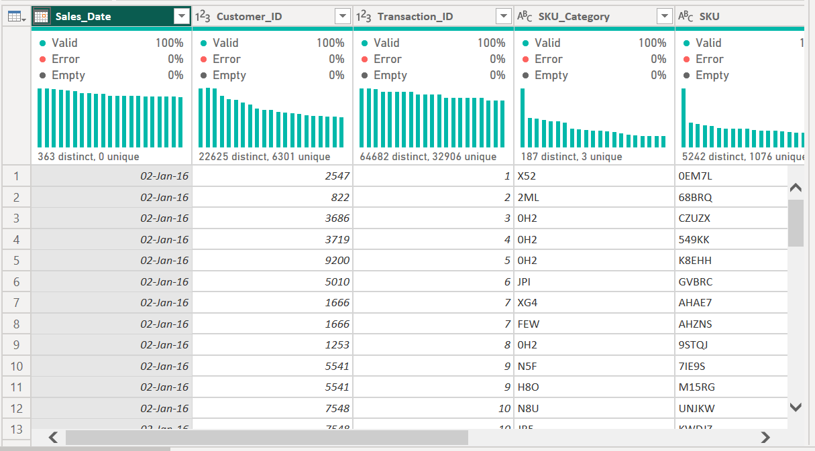
FIG NO :1 (DATA TRANSFORMSTION)
- DAX Function:
Here are the DAX formulas that could be used to generate each of the metrics shown in your image:
- Total Sales (Sum of Sales_Amount):
Total Sales = SUM ('RETAIL SALES'[Sales_Amount])
- Total Quantity (Sum of Quantity):
Total Quantity = SUM ('RETAIL SALES'[Quantity])
- Sales per Customer (Average Sales Amount per Customer):
Sales per Customer = DIVIDE ([Total Sales], DISTINCTCOUNT ('RETAIL SALES'[Customer_ID]))
- Total Customers (Distinct count of Customer_ID):
Total Customers = DISTINCTCOUNT ('RETAIL SALES'[Customer_ID])
- Average Purchase Frequency (Average number of transactions per customer):
Avg Purchase Frequency = DIVIDE ([Count of Transactions], [Total Customers])
Count of Transactions = COUNT ('RETAIL SALES'[Transaction_ID])
- Average Order Value (Total Sales divided by total transactions):
Average Order Value = DIVIDE ([Total Sales], [Count of Transactions])

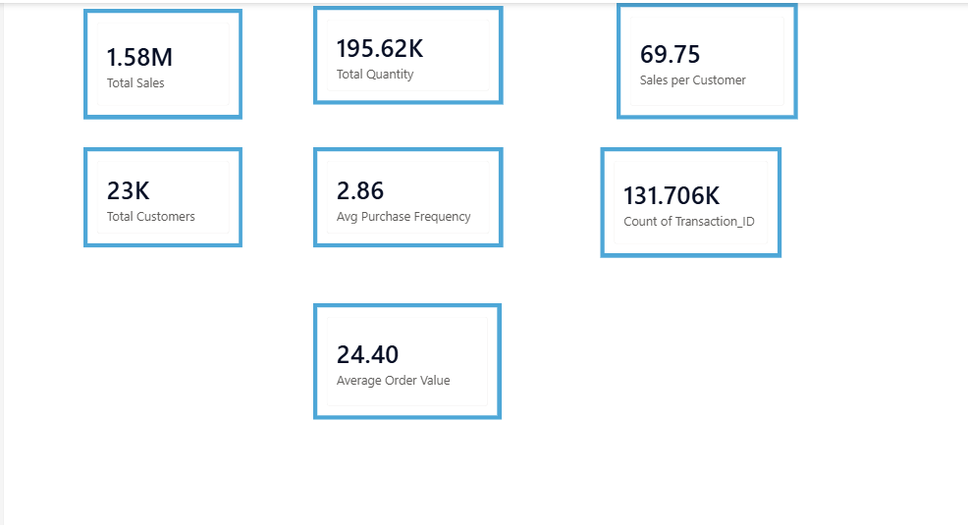
FIG NO: 2 (DAX MEASURES)
- Dashboard Creation:
The dashboard provides a comprehensive overview of retail sales performance, focusing on key metrics and patterns:
DESCRIPTION OF THE DASHBOARD:
1. Key Metrics at the Top
- Total Sales ($1.58M): Overall revenue generated from sales.
- Total Quantity (195.62K): Total units sold.
- Total Customers (23K): Number of unique customers.
- Total Transactions (131,706): Number of individual purchase transactions.
- These metrics give a quick snapshot of overall business performance.
2. Sales Trend by Month (Line Chart)
- Illustrates sales performance over the months.
- Shows fluctuations, with peaks likely around May and December, indicating seasonal influences or promotional periods.
- A rising trend towards December suggests end-of-year sales boost.
3. Total Transactions and Quantity Breakdown (Pie Chart)
- Visualizes the proportion of total transactions versus total quantity.
- Indicates that most transactions involve smaller quantities, with a significant number of single-unit purchases.
4. Sales Contribution by Category (Pie Chart)
- High Category dominates with 57.36% of total sales.
- Medium and Low categories contribute roughly 34% and 8.5%, respectively.
- Implies high-value or high-demand products are concentrated in the "High" category.
5. Sales by Product Category (Bar Chart)
- Displays the sales volume per SKU category.
- "9ZX," "01F," "8HU," "1EO," and "0H2" are the top-performing categories, indicating popular products.
6. Customer Purchase Behavior (Table)
- Shows individual customer transactions with their average transaction value.
- Highlights high-value customers who make large or frequent purchases.
7. Additional Filters & Slicers
- Date and customer filters enable detailed drill-downs.
- Allows analysis of specific periods or customer segments.
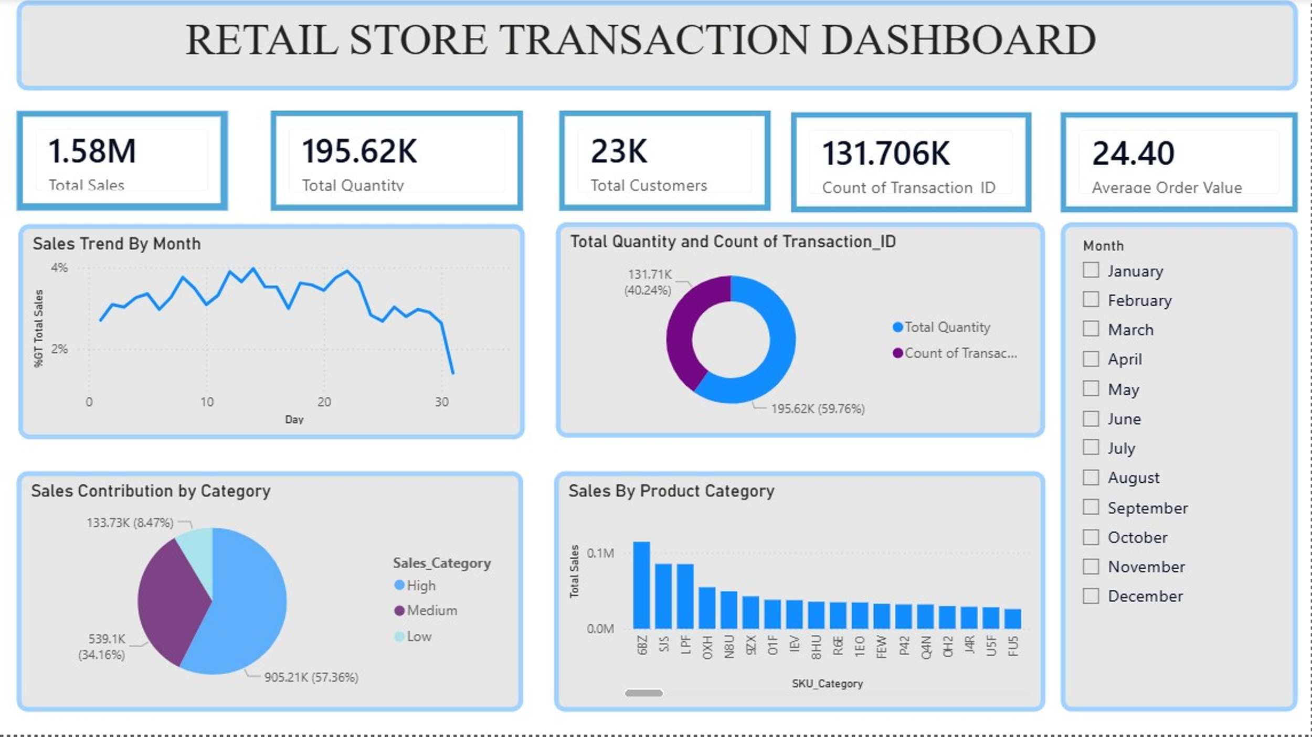
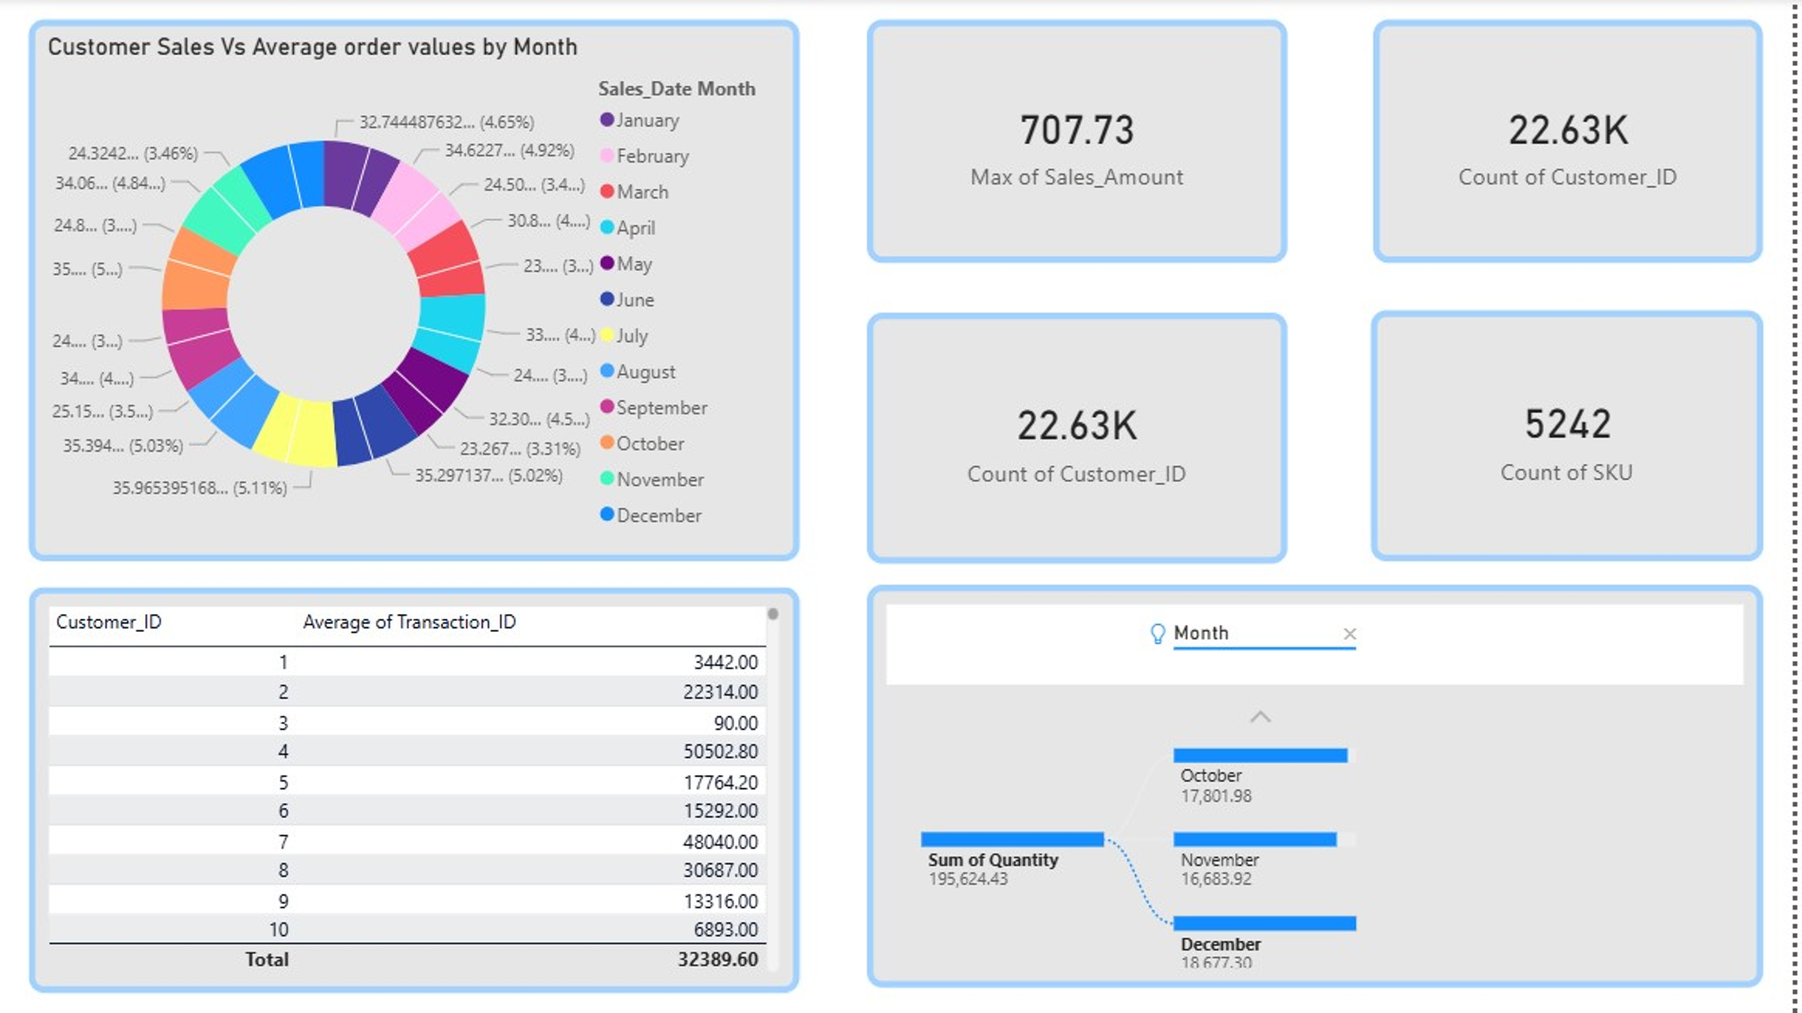
FIG NO: 3 & 4 (DASHBOARD)
INSIGHTS & ANALYSIS REPORT:
PROJECT OBJECTIVES:
- Analyze Overall Sales Performance
  - Calculate total sales revenue, total units sold, and transaction counts over the specified period.
  - Identify trends and seasonal patterns in sales data.
- Segment and Profile Customers
  - Determine the number of unique customers.
  - Analyze customer purchase frequency and average spend per customer.
  - Identify high-value and frequent customers for targeted marketing.
- Product and Category Performance
  - Evaluate sales contribution by SKU category and individual SKUs.
  - Identify top-performing products and categories.
  - Detect underperforming SKUs for potential inventory adjustments.
- Transaction Analysis
  - Assess average order value and purchase size.
  - Analyze transaction patterns, including average quantities per transaction.
- Identify Sales Trends and Patterns
  - Detect peak sales periods and seasonal fluctuations.
  - Understand the impact of promotional events or seasonal factors on sales.
- Support Business Decision-Making
  - Provide insights for inventory management, marketing strategies, and sales forecasting.
  - Identify opportunities for sales growth and customer engagement.
- Data Quality and Consistency
  - Validate data integrity, ensuring accurate transaction records.
  - Prepare data for advanced analytics and reporting
KEY OBSERVATIONS, PATTERNS, AND ANOMALIES
1. Overall Sales Performance
- The total sales generated amount to approximately $1.58 million, with a total transaction count of 131,706 and over 22,000 unique customers.
- The average order value is relatively consistent at around $24.40.
2. Sales Trends and Seasonality
- Monthly sales pattern indicates a gradual decline in total sales toward the end of the month, with a noticeable drop around the 30th day.
- There is a consistent sales contribution across months, but the overall trend suggests some fluctuations, possibly influenced by seasonality or promotional periods.
3. Customer Purchase Behavior
- A small proportion of customers account for a significant portion of sales, indicating a highly concentrated customer base.
- The average transaction value per customer varies significantly, with some customers regularly making high-value purchases (e.g., Customer_IDs 1, 8, 166, 482).
4. Product and Category Performance
- The top-selling product category is "High," which accounts for over 57% of total sales, followed by "Medium" and "Low" categories.
- SKU category "X52" is the most popular, with the highest total sales, suggesting high demand for specific products within this category.
- Certain SKUs like "CZUZX," "W22UD," and "LPLTZ" are frequently purchased, indicating their popularity.
5. Sales Distribution and Anomalies
- The maximum sales amount in a single transaction is approximately $707.73, which may be an outlier or a high-value bulk purchase.
- There are some transactions with unusually high quantities (e.g., 60 units of "JI5" by Customer_ID 4707), which could be bulk orders or inventory adjustments.
- A few SKUs (e.g., "U5F," "N8U") appear multiple times with varying quantities and sales amounts, reflecting ongoing demand.
6. Customer and SKU Anomalies
- The number of distinct SKUs (22,563) versus total transactions indicates a wide product variety, although a handful of SKUs dominate sales.
- Certain customers, like Customer_ID 166, show high purchase volumes, suggesting they might be key accounts or wholesale buyers.
- Some transactions involve multiple units (e.g., 3 or more), which could influence sales revenue disproportionately compared to individual purchases.
ACTIONABLE RECOMMENDATIONS
- Optimize Inventory for Peak Seasons
  - Increase stock levels of top-performing SKUs such as "9ZX," "01F," "8HU," and "0H2" ahead of peak sales periods like December to prevent stockouts and maximize revenue.
- Target High-Value Customers
  - Identify and develop loyalty programs for high-spending and frequent customers to boost retention and encourage repeat purchases.
- Promote Bundling & Cross-Selling
  - Leverage purchase patterns (e.g., "OV1P9" with "N8U") by creating product bundles and cross-promotions to increase average order value.
- Personalized Marketing Campaigns
  - Use customer purchase data to segment audiences and deliver personalized offers, especially to customers with repeat transactions or high lifetime value.
- Focus on High-Contribution Categories
  - Allocate marketing resources and promotional efforts toward SKU categories like "High" to sustain and grow their contribution to overall sales.
- Enhance Upselling Opportunities
  - Educate sales staff and optimize online platforms to recommend complementary products at checkout, based on frequent co-purchases.
- Monitor Seasonal Trends Continuously
  - Implement ongoing sales trend analysis to adapt inventory, marketing, and staffing strategies dynamically during high and low seasons.
- Reduce Inventory Waste
  - Identify underperforming SKUs to consider discontinuation or promotional clearance, freeing up space and funds for better-selling products.
- Data-Driven Forecasting
  - Develop predictive sales models using historical data to anticipate future demand and optimize supply chain operations.
- Improve Data Collection & Tracking
  - Enhance data capturing processes to include customer demographics and preferences for more refined segmentation and targeted marketing.
CONCLUSION:
- The data presents a comprehensive record of retail transactions over a specific period. It encompasses details such as transaction dates, customer IDs, transaction IDs, SKU categories, specific SKUs, quantities purchased, and sales amounts. The variety of SKUs and the range of sales figures highlight the diversity of products offered and the varying levels of customer demand. By analyzing this information, businesses can identify their most popular items, understand customer purchasing behaviors, and detect sales trends over time.
- This dataset serves as a valuable resource for making informed decisions about inventory management, marketing strategies, and sales optimization. Overall, it reflects an active retail environment with significant opportunities for data-driven insights to enhance operational efficiency and profitability.

THANK YOU

